₹

$
€
£
₡

¥

GET THAT GRANT

The Grant Winning Success Formula

Learning and Action Plan
Workbook 2- Project Planning 101
The Community Entrepreneur
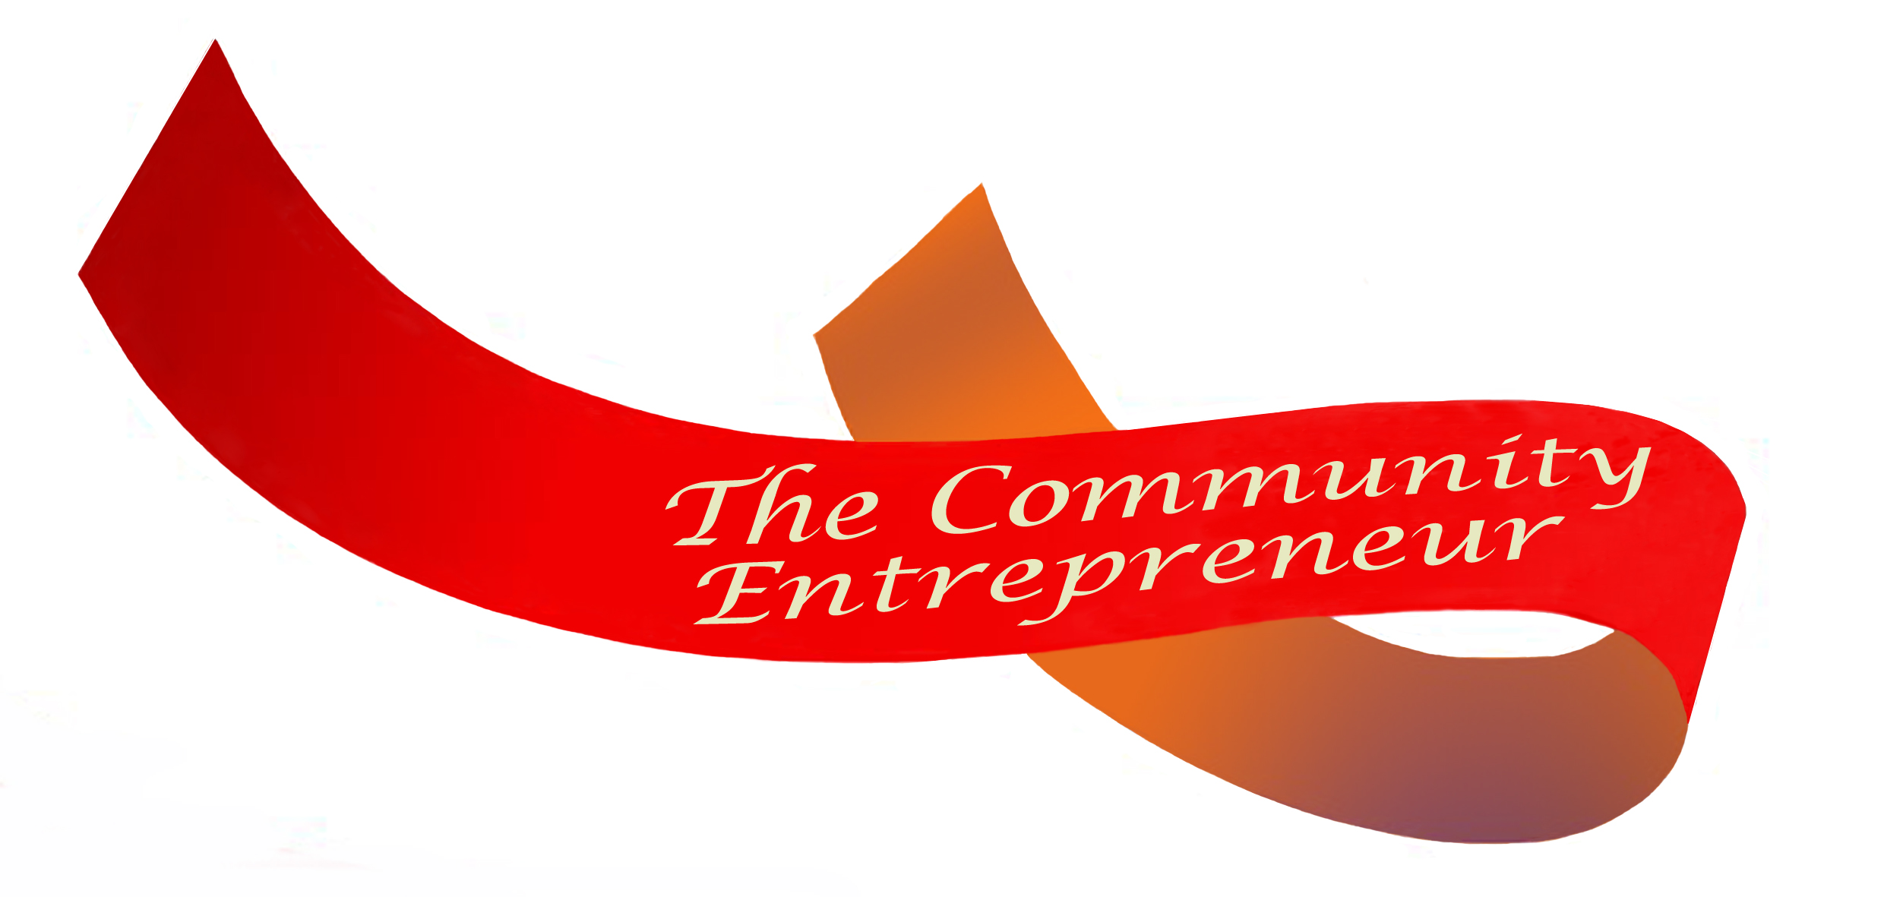

Get That Grant © The Community Entrepreneur

Copyright
This training program is the copyright of The Community Entrepreneur. It may only be used as a learning resource for the purchaser of the program. If the purchaser is an organisation (license), the training program can be used by up to three people engaged with the organisation at any one time. A license must be purchased from The Community Entrepreneur for additional users. The training program cannot be shared or copied to anybody outside of the organisation for which the program was purchased.

The material in this training program must not be reproduced, copied or used for any other purpose without the written permission of the copyright owner.
Module 2

Project Planning 101

You’ve checked the Guidelines, you’ve got a good idea what the funder requires and you’ve done your homework and decided to apply for a grant.
BEFORE YOU START … Here are some fundamental questions:
How does this project fit with your organisational Purpose and Plan?
__________________________________________________________________________________
__________________________________________________________________________________
__________________________________________________________________________________
__________________________________________________________________________________
What evidence do you have to demonstrate that there is a ‘need’?
Data (eg census, economic, research)
__________________________________________________________________________________
__________________________________________________________________________________
__________________________________________________________________________________
Feedback (eg customers, community consultation, stakeholders)
__________________________________________________________________________________
__________________________________________________________________________________
__________________________________________________________________________________
Other (eg evaluation, policy and planning documents*)
__________________________________________________________________________________
__________________________________________________________________________________
__________________________________________________________________________________
* referring to policy and planning documents from local and regional government for example, are good indicators of how your proposed project also fits with local and regional priorities.
How will this project lead to sustainable activity/outcomes after the funding ceases?
__________________________________________________________________________________
__________________________________________________________________________________
__________________________________________________________________________________
What is the potential of this project to take over ‘who we are’?
__________________________________________________________________________________
__________________________________________________________________________________
Can you prove innovation?
Unless the funding is recurrent, funding bodies prefer to fund projects that are innovative – new to your organisation, new to your community, or new to the system within which you operate.
These criteria are unlikely to succeed:
Are you looking for a different way to fund existing positions or tasks?
Are you looking for funds to continue an existing project?
These criteria are likely to be considered:
Is this project innovative for your organisation or community?
If it is a follow-on to an existing project, does your project add a new dimension?

Underpinning Principle - Good projects = 80% planning / 20% activity

The Who, What, Where, Why, When and How Questions

Plan out what needs to be done, when, where, how and to/by whom.
These questions will appear in your funding application forms. They come in various guises and the words may be interchangeable, but they will be there. Here is a list from a variety of application guidelines that show examples of what might constitute:

Who
- List the details of Primary Partner Organisations, including names addresses and other relevant information. These are the organisations you will work very closely with throughout the life of the project.
- Details of applicant.
- Population group/demographic the project will target - Please specific the diverse groups who will benefit from your project?
- Who is going to be involved in the project and what will their role entail? Include project managers, volunteers and community groups.

What
- What are you going to do?
- List details of your project plan including project stages, key tasks, dates and milestones.

Where
- Where will your project happen?
- In which local government area will your project happen?

When
- When will your event take place?
- Please list the start and end dates of your project?

Why
- Provide details of why this project is needed. If this is an extension to an existing project you will need to demonstrate why this extension is needed.
- What is the business need or gap that this project addresses?

How
- State how you plan to engage the wider Australian community through your event
- State how your event showcases the benefits of multiculturalism and promotes awareness and acceptance of cultural, religious and linguistic diversity
- How do you expect to build the skills and capacity of your organisation and/or your partner organisation/s throughout the funding period? Describe how your organisation will manage the project to ensure outcomes are met within the project timeframe and budget.
- How will the project address this need/gap?
- How will the project support the organisation to build its capacity?
- Explain how this project will address the identified need and the long term benefits it will produce?
- How will the outcomes be sustained beyond the life of this project?

It is a good idea to use the following table to put together your ideas for a project that you would like to see funded when the right opportunity comes along. Brainstorm your who, what, where, why, when and how questions, and together with a budget (see the template in workbook 3), store in a drawer ready to be used when the time is right,

Be ready for them!

Exercise 7 - The Who, What, Where, Why, When and How Questions
Use this table to dissect the WWWWWH questions and draft responses for your grant application:
QUESTION TYPE | QUESTION(S) IN APPLICATION FORM | YOUR RESPONSE
Who
What
Where
Why
When
How

Planning the Detail – Preparing the Project Plan

The one way to accurately put together your budget is to carefully plan your project – breakdown the tasks, decide a time frame for the tasks to take place and allocate resources.
Start with an overview of the tasks, then break them down into detail and allocate them to stages (eg stage x research)
Briefly break down the tasks you will do, who will be involved and when.

If this is your first time consider using sticky notes to prepare your plan before transferring to the following table. Give each note a task and arrange on the desk according in sequence with a set of notes at the top representing your timeframe (days, weeks or months).

Consider how much time is realistic for each task and that enough resources are available to carry out the plan successfully. More sophisticated planning tools will be explored in our project management training program

Exercise 8 – Project Plan
Break down your activities into time frames (months used as an example), stages and activities. Mark the boxes relating to the planned timeframe for activities with an x.
STAGE/ACTIVITY | Person(s) | Month 1 | Month 2 | Month 3 | Month 4 | Month 5 | Month 6 | Month 7 | Month 8 | Month 9 | Month 10 | Month 11 | Month 12
Project Management
List tasks associate with Project Management, including steering/ reference group meetings, engaging consultants and project communication (Communication may be listed as a separate stage for large projects)
Stage 1 – (name of stage)
List tasks/deliverables associated with this stage

STAGE/ACTIVITY | Person(s) | Month 1 | Month 2 |  | Month 3 | Month 4 | Month 5 |  | Month 6 |  | Month 7 |  | Month 8 |  | Month 9 |  | Month 10 |  | Month 11 |  | Month 12
Project Management
Stage 2 etc
List of tasks/deliverables associated with each stage
Stage 3 etc
Evaluation and Reporting
Evaluation plan development
Evaluation activities
Reporting milestones

Replace ‘month’ with period of time eg day, week, month etc
Add rows and sections as required

Exercise 9 – Project Resource Plan
Use the Stages/Tasks column to plan for your resources (add rows as necessary)
Incorporate the roles that partners will be playing (eg provision of staff, venues, services and activities). Use Exercise 3 to inform which items may be eligible for grant funds. Insert rows as required.
STAGE/ACTIVITY | HUMAN RESOURCES |  | PHYSICAL RESOURCES |  | TRAVEL AND OTHER SUNDRY EXPENSES
 | Grant | Non-grant | Grant | Non-grant | Grant | Non-grant
Project Management
Task 1
Stage 1 – (name of stage)
Stage 2 etc

STAGE/ACTIVITY | HUMAN RESOURCES |  | PHYSICAL RESOURCES |  | TRAVEL AND OTHER SUNDRY EXPENSES
 | Grant | Non-grant | Grant | Non-grant | Grant | Non-grant
Stage 3 etc
Evaluation and Reporting
Evaluation plan development
Evaluation
Reporting milestones (eg mid-term report)
Final Report

Project Plan
Have you planned out the activities, tasks and timelines?
Have you been able to group or divide the activities into stages?
Have you allocated roles to these tasks?
Have you included volunteer input into the plan (if applicable)?
Have you included resource requirements, including organisational resources?
Have you double-checked the Project Plan with colleagues to spot errors/omissions and capacity to deliver the project (eg deliverables, timelines, resources)?

It is best to brainstorm the plan with others. These may be colleagues or potential partners.
If you are planning to work with partners:

Project Partners (if applicable)
Have you met with partners to brainstorm the plan?
Do you have access to the partners you will need for this project?
Have you met with the partners (if applicable) to put together the project plan?
Is each partner willing and able to provide an active role in the project?
Are partner roles clearly identified in the Project Plan?
Have all partners committed to the Project at the senior level?
Can they commit to a memorandum of understanding or a letter of intent?

Working with partners to develop the project plan helps to avoid misunderstandings later on.

Project Planning 101 Summary
In this module we have covered the basics required to demonstrate that you have carefully planned what you are going to do:
- The project you will use the money for must fit with your organisational Purpose and planning
- The evidence of need is clearly demonstrated
- The project is ‘new’
- The project leads to sustainable activities/outcomes
- be ready with the who, what, where, why, when and how questions – for any project proposal!
- Preparing the plan of activities / timeframe
- Planning the resources
- Involving partners in the planning process

Now you’ve prepared your project plan, let’s look at the budget in Module 3

